Intensity Control of Home Appliances

Using MQTT Protocol

Rohan N Kalpavruksha Roshan N Kalpavruksha Akhil V Nayanegali  
 Electronics and Communication Electronics and Communication Electronics and Communication  
 PES University PES University PES University Bangalore, Karnataka Bangalore, Karnataka Bangalore, Karnataka[*rohankalpavruksha@yahoo.com*](mailto:rohankalpavruksha@yahoo.com)[*ralpavruksha@yahoo.com*](mailto:ralpavruksha@yahoo.com)[nay.akhil@gmail.com](mailto:nay.akhil@gmail.com)

Mridhula SriharshaDr. Anuradha M  
Electronics and Communication Electronics and Communication  
 PES University PES University Bangalore, Karnataka Bangalore, Karnataka  
[*mridhulasriharsha@gmail.com*](mailto:mridhulasriharsha@gmail.com)[anuradha@pes.edu](mailto:anuradha@pes.edu)

*Abstract* - Controlling various basic home appliances is a major challenge for physically impaired and elderly people, with which smart automated homes are in demand. Internet of Things gives the accesses to control some parameters of devices at home remotely through the Internet. Message Queuing Telemetry Transport (MQQT) is used for transferring data from user to devices via Wi-Fi, as it is a simple and light weight messaging protocol. In this work, a control system using MQTT protocol is proposed that helps visually/physically challenged and aged people to control various home appliances. Implementation of a novel smart watch design has been done with NodeMCU and accelerometer for controlling the intensities of devices using hand gestures as input. The system controls the intensity of bulb and regulate the fan at different levels is carried out using IoT devices, through various input methods such as voice using Google assistant, slide bar using ubidots and gesture using smart watch. This system is designed with low cost and thus useful for specially challenged.

Keywords—Home automation; IoT; Gesture; Voice controlled; Slide bar; MQTT protocol

# Introduction

We currently live in an era where our everyday chores are turning towards the use of smart technology. With advancement of automation technology, life obviously gets simpler in many ways. Internet of Things gives the accesses to control some parameters of devices at home remotely through the Internet. The Internet of Things is a network of embedded objects that helps in connecting and exchanging or transmission of data with other devices via internet.

Day by day the number of internet users is rapidly increasing over the past and has become a part of life. IoT refers to physical objects network that are embedded with sensors, software and other technologies and a network of embedded objects that helps in connecting and exchanging or transmission of data with other devices via internet We now have developed a system which can control the intensity of light and speed of fan by various input methods that is relatively affordable, simple to implement, or configure and users friendly. We aim to create a wrist band for specially challenged people which can help them control light/fan at various levels.

In this paper, the authors focus on controlling the intensity of bulb and fan at different levels by making use of IoT devices through various input methods such as voice using google assistant, slide bar using ubidots server and based on our gesture with the help of an accelerometer which in turn helps avoid unnecessary wastage of power.

Message Queuing Telemetry Transport (MQQT) is used for transferring data from user to devices via Wi-Fi, as it is a simple and light weight messaging protocol. The specifications of MQTT such as MQTT being built on top of TCP and lets TCP do a lot of hard work and no payload definitions was specified has made us take up this protocol to solve the problem stated. It provides many advantages such as efficient distribution of information, increased scalability, maximizes available bandwidth, reduces update rate to seconds.

# LITERATURE SURVEY

We have used an innovative way to control light bulbs with the help of CoAP application of smart clothing. It gives users a new experience which traditional lighting control cannot make. But this system experiences delays in processing of gestures. Our solution aims at making the interaction between the user and home appliances more easier and absolutely natural [1].

Advanced technique of monitoring a light bulb built on CoAP for smart clothing provide the consumers a fresh knowledge which outdated lighting control cannot mark. They have a lesser reaction time. Our result will make the communication between the human and lights more normal [2].

OpenCV is used for correct gesture recognition. It is the module named ‘text to speech’ that converts the test provided as input into the speech form. It provides a user-friendly way to display result. OpenCV used is not as robust as other method as sufficient lighting is needed. This method is depended on background and objects [3].

The authors have used NFC wearable wristband which for operating automation systems from a distance [4]. This wearable wristband system uses NFC technology which helps in operating home appliance around a radius of 10m.

We have used CoAP protocol and sensors of different types. Temperature sensor and esp32 are connected and it a acting like a client. Later many types of leds at our house is connected to esp8266. Soil moisture sensor is used for knowing plant’s health status in our house and ultrasonic is used for status of the water level in storage tanks. CoAP uses UDP which is not reliable [5]. Therefore, we have used MQTT which uses TCP.

The innovations enable the activities work more efficiently by reducing the energy consumption. If the data transmission delay is reduced, the better and more efficient the processes in the smart houses will be done. But in this technique, the authors did not account the security aspect of the innovation [6].

# METHODOLOGY

The proposed system is to allow the user with any android enabled device and smart watch to run downloadable software on smart phones or mobiles. The authors developed a system of home automation which helps the user to control intensity of light or vary the speed of fan connected to Wi-Fi.

System recognizes the user inputs and data is published with the help of Node MCU via MQTT Broker which is then subscribed with the help of another Node MCU at electric devices.

Wi-Fi Module ESP8266 is used which is self-contained SOC integrated with TCP/IP protocol stack and provides all microcontroller access to the Wi-Fi network [5]. The ESP8266 hosts an application or offloads functions of all Wi-Fi networks from other processor of any application, which then reaches dedicated device and helps user control the speed of fan and intensity of light at various levels.[6]

MQTT protocol is used due to its advantages such as, distribute information more efficiently, reduction of update rates to seconds, it is best-suited for sensing and controlling remotes, maximizes bandwidth that is free, totally light weighted and increase scalability.

* Setup of MQTT broker using the Ubidots

Ubidots, platform of Internet of Things (IoT) that allows prototype and expansion of IoT applications for businesses. From any Internet-enabled device, use the Ubidots platform to transfer data to the cloud. After that, we set up actions and alerts based on the real-time data and use visual tools to uncover the value of data. Data variables, even values and many more are all accessible using Ubidots' REST API. We need API Key for API, which supports both HTTP and HTTPS.

The following steps are used to setup MQTT broker on the Ubidots cloud:

1. Create an account on the Ubidots website.
2. From the Dashboard, select Devices to display a drop-down menu of options.
3. Click on devices again.
4. Hover your mouse over the '+' icon on the right side of the screen, then click the smaller '+' icon.
5. Select the "blank device" block. Fill in the device name and label fields. You have successfully created the device.
6. Select the newly created device from the devices list.
7. Select the 'Add Variable' block, then the 'Raw' option. Assign a name to this variable. A notification should appear that says "Variable Successfully Created."
8. Return to the dashboard. To select a widget, click the ‘+' icon and select the widget you want. I chose the slider option to give the appliance a slider control.
9. After you've chosen the widget, go to ‘+ add variable' and choose the newly formed device. Then select the variable you just made.
10. To build a widget, fill in the widget's fields and then click the green tick in the bottom right.
11. You've set up your MQTT broker. The appliance's parameters can be controlled and monitored.

* The Subscriber Circuit

The Subscriber circuit is the main circuit responsible for controlling AC voltage. The microcontroller used is NodeMCU, an open-source hardware and software programming platform which is based on ESP8266 [11].It has an inbuilt WI-FI support with TCP/ IP protocol.

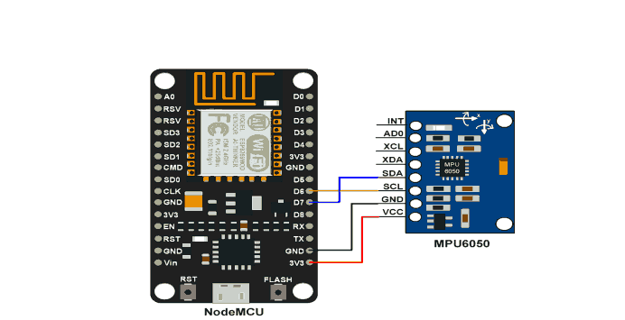

Fig.1 NodeMCU with MPU6050

The NodeMCU circuit is connected to the internet through WI-FI. It receives data from the MQTT server or the cloud. Upon receiving the data, the circuit controls the various appliances connected to it. The method used for controlling the AC voltage is the Leading-Edge Phase dimming method.

The circuit is split into two sections:

1) Circuit with a Zero Cross Detector

2) Triac-based phase/angle control

* **Zero Cross Detector circuit**

To regulate the AC voltage, it is required to identify the zero crossings as shown in Fig. 2. The AC signal frequency in India is 50 HZ, and it is alternating in nature. As a result, whenever the signal approaches zero, we must use the Zero-Crossing Identification Technique to identify that position. The dimmer is synchronized using zero-crossing.

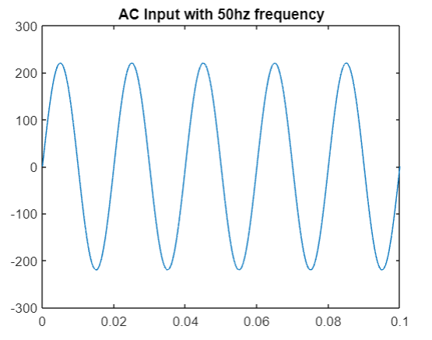

Fig. 2 AC Input with 50Hz frequency

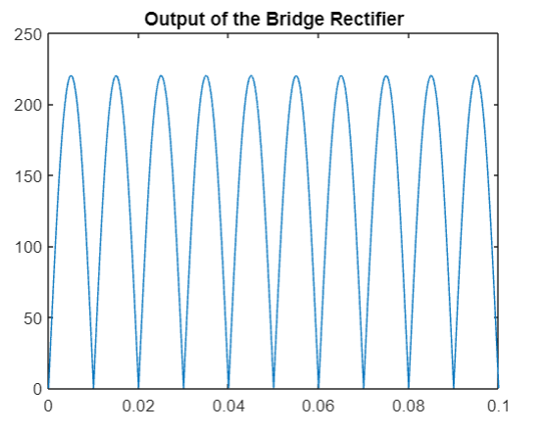

Fig. 3 Output of the bridge rectifier

When the transistor conducts, the output at pin 5 is pulled down to 0. The input at the D6 pin of the NodeMCU receives a digital LOW, when the output of the Bridge Rectifier passes through the zero points as shown in Fig. 3. The IR led of the MCT2E is off. This results in an open circuit of the transistor. The output of pin 5 is pulled up to 5v. The input at the D6 pin of the NodeMCU receives a digital HIGH.

The above operation results in the generation of pulses every time the AC signal crosses the zero value. For an AC signal having 50Hz as its frequency, one cycle has a duration of 20ms. The signal crosses the zero value at the half cycle which is 10ms. So this generates pulses every 10ms as shown in Fig. 4.

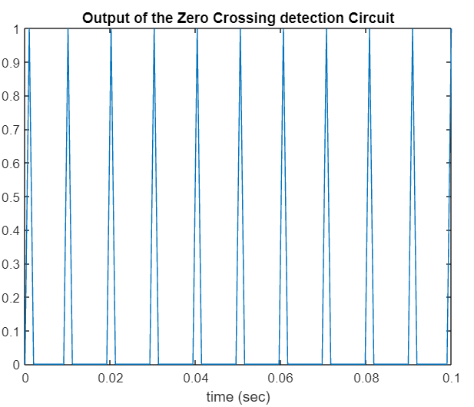

Fig. 4 Output of Zero Crossing detection Circuit

* **Phase control using TRIAC**

The second part of the subscriber circuit is the phase/ angle control using TRIAC. This circuit mainly includes a TRIAC BT 136 and an optocoupler MOC3021 . TRIAC can convert high voltages and currents, as well as the positive and negative cycles of an AC waveforms. Hence, it is well suited for a variety of power switching applications. The approach is known as leading-edge phase dimming.

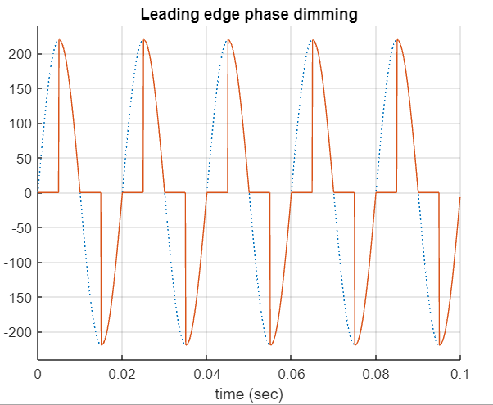

Fig. 5 Comparison of AC wave with the output of leading phase edge dimming

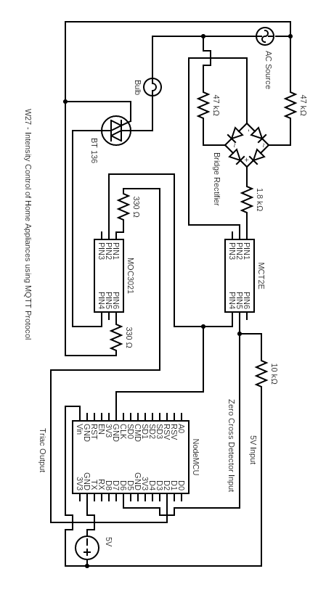

Fig. 6 Schematic of the Subscriber Circuit

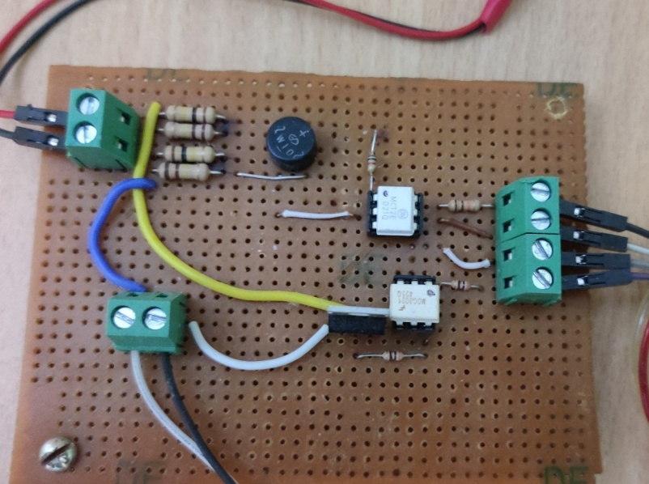

Fig. 7 The Subscriber Circuit

The connections between NodeMCU and MPU6050 have been shown in Fig. 1. The accelerometer of the MPU6050 is used to control the intensity of the home appliances. The Y-axis of the accelerometer function is used to adjust the intensity of the appliances. The MPU6050 sends the values continuously to the NodeMCU. The values change based on the tilt angle of the wrist. When the wrist is tilted towards the left, the voltage value decreases resulting in reduction of the light intensity. Similarly, when wrist is tilted towards right, the voltage value increases resulting in the increase of light intensity.

ad

* + GESTURE-BASED WRIST BAND

The gesture-based wristband mainly consists of NodeMCU and a sensor moduleMPU-6050. To power the wristband, we have used a 18650 lithium-ion battery which has a capacity of 1200 Mah with a voltage rating of 3.7V.

Transmission of data happens between devices with the help of just two wires in I2C circuit:

Serial Data (SDA) - It is a channel of transmission for data between master and slave[1]

Serial Clock Line (SCL) — It is a line that carries clock signal [1]

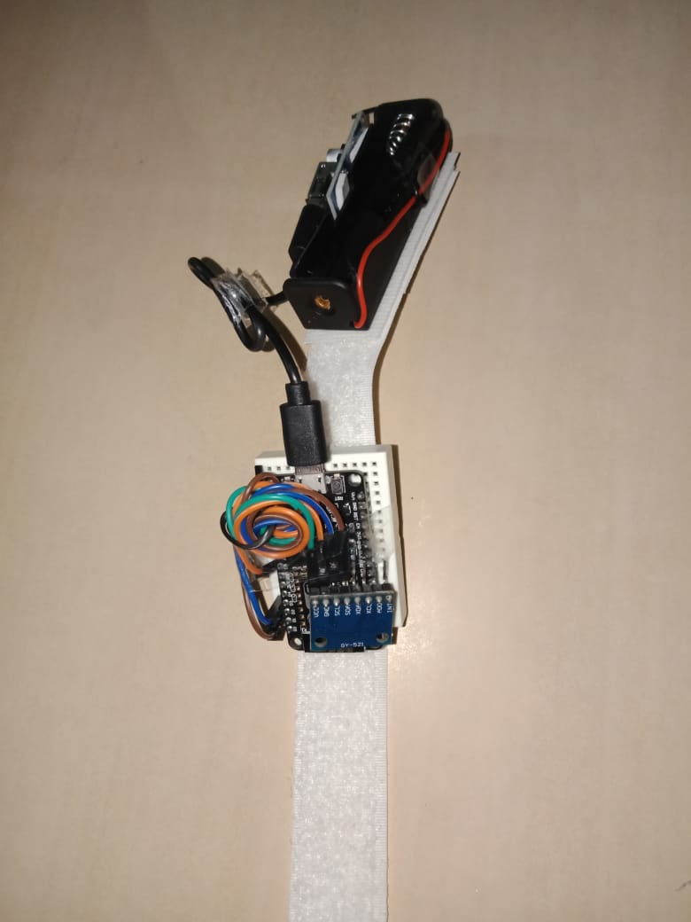

Fig 8 Design of proposed wristband (1)

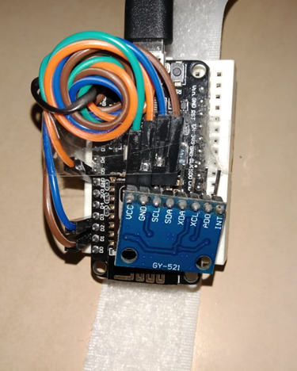

Fig 9 Design of proposed wristband (2)

VOICE CONTROL THROUGH GOOGLE ASSISTANT

Google assistant

It is a helper boot activated by voice that is created by Google. Almost all Android devices have Google Assistant built in. The phrase "Hey Google"/"Ok Google" is used to communicate with the Google Assistant

IFTTT

“If This Then That (IFTTT) is a software solution that links various developers' apps, technologies, and services in order to activate one or more automated systems using those apps, equipment, and services”. “Applets, or basic conditional statements, are created using IFTTT”. [4]

Webhooks

In web development, a webhook is a technique of using custom callbacks to enhance or change the behavior of a web page or web service. A webhook delivers data in real time to other apps, so you can see it straight away. [4]

Creating applets using IFTT

1. Once you have downloaded the app, create an account by logging into your Gmail account.
2. Click on create to make a new applet.
3. Click on add in the If this block.
4. Choose the google assistant services from the list.
5. In the next option, click on say a phrase with number option.
6. Create simple commands like “Turn on the Bulb for # percent”
7. Once the If this block is created, click on then that block.
8. Choose webhooks from the list of services.
9. In the URL block, paste the Ubidots webhook link with the Device name that you have configured in the Ubidots dashboard and the Ubidots account token number.
10. Choose the GET option for the method option.
11. Choose application/JSON option for the content-type option.
12. In the Body block, type the variable name and the data type that you have configured in the Ubidots dashboard.
13. The applet has been created.

Hey Google/ Ok Google is the hot keyword used to engage with the google assistant. The voice command is received by Google Assistant, which then converts it to data. Interpreted data is analyzed and checked whether the command is for IFTTT or some other application [4]. For example, If I say the phrase “turn on the bulb for 30%”. Google Assistant interprets the phrase as BULB =30% and the interpreted data is sent to the IFTTT. The IFTTT interprets this BULB= 30% as the trigger and the action field is activated to send the number field 30 to Ubidots MQTT server. The number received by then is displayed on the dashboard. The Subscriber circuit NodeMCU receives this value and the subscriber circuit operation is executed to adjust the intensity of the appliance as per the value received from the MQTT server.

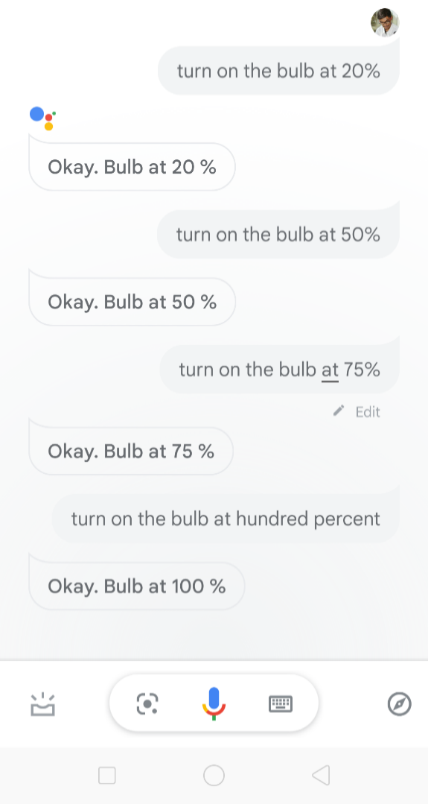

Fig 10 Voice Commands in Google Assistant

# RESULT

Intensity of bulb and fan gets varied with different inputs like gesture, voice, slide bar and integrated all three methods.

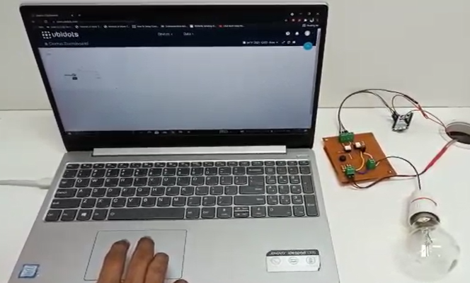

Fig 11 Slide Bar

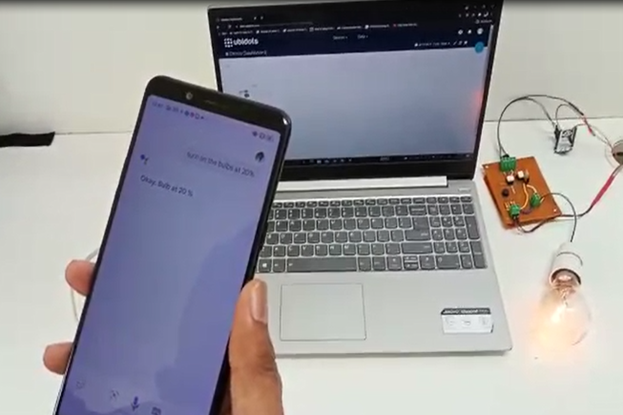

Fig 12 Voice Commands

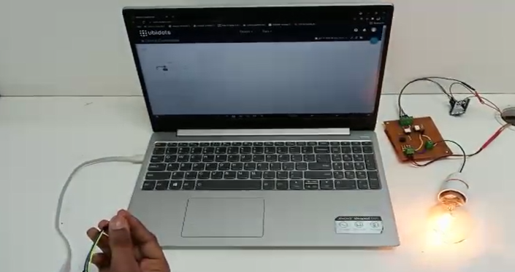

Fig .13 Gesture Based

# CONCLUSION

As a technical advancement, the interactivity based on gesture proves to be a potential mode to interact between human beings and electrical equipment. Gadget design that is proposed provides consumers with a novel experience that standard appliance control cannot provide, and our approach will improve the user-appliance interaction. Also, as the device be connected to the internet, we will be able to have control on any of the appliances at our home from any point of place in the whole world. This system can be incorporated into a smart watch which will have an inbuilt accelerometer and also the Google Assistant.

##### References

* 1. Assad Mohammed, Amar Seeam, Xavier Bellekens z, Kamila Nieradzinska x, Visham Ramsurrun , “Gesture based IoT Light Control for Smart Clothing”, 2016 IEEE International Conference on Emerging Technologies and Innovative Business Practices for the Transformation of Societies (EmergiTech), Avaliable online: [10.1109/EmergiTech.2016.7737326](https://www.researchgate.net/deref/http:/dx.doi.org/10.1109/EmergiTech.2016.7737326)
  2. Sajid Nagarboudi Patel a, R.D.Salagarb ,”A Review on Iot Light Control for Smart Clothing using Gesture Control”
  3. Yash Govilkar, Dr. Rupesh Jaiswal , “A Gesture Based Home Automation System” , International Journal for Research in Applied Science & Engineering Technology (IJRASET**),** *Volume 7 Issue XI, Nov 2019,* Available online: <http://doi.org/10.22214/ijraset.2019.11081>
  4. Osheen Bindroo, Komal Saxena, Sunil Kumar Khatri, “A Wearable NFC Wristband for Remote Home Automation System”, 2017 2nd International Conference on Telecommunication and Networks (TEL-NET), Available Online :[10.1109/TEL-NET.2017.8343563](https://doi.org/10.1109/TEL-NET.2017.8343563)
  5. Ravi Kishore Kodali, Borra Yatish Krishna Yogi, Gudibanda Nagesh Sharan Sai, Jehova Honey Domma, “Implementation of Home Automation Using CoAP”, 28-31 Oct. 2018 [TENCON 2018 - 2018 IEEE Region 10 Conference](https://ieeexplore.ieee.org/xpl/conhome/8643125/proceeding)
  6. Kamelya Dehghani Kohnehshahri, Mohammad Hasan Kargar, Fatemeh Soleimani-Roozbahani, “The Effect of Using COAP Protocol on Reducing Energy Consumption in Smart Houses”, Sep 8, 2018 Int. J. Advanced Networking and Applications Volume: 10 Issue: 03 Pages: 3843-3852 (2018) ISSN: 0975-0290
  7. K. Loga Priya1, Mrs. S. Saranya2,” Voice-Activated Home Automation using NodeMCU”, International Research Journal of Engineering and Technology (IRJET), Volume: 07 Issue: 02 | Feb 2020
  8. Sajid Nagarboudi Patel a, R.D.Salagarb ,”A Review on Iot Light Control for Smart Clothing using
  9. Yash Govilkar, Dr. Rupesh Jaiswal , “A Gesture Based Home Automation System” , International Journal for Research in Applied Science & Engineering Technology (IJRASET), *Volume 7 Issue XI, Nov 2019,* Available online: <http://doi.org/10.22214/ijraset.2019.11081>
  10. Indu Dokare, Raghav Potdar, Rahul Sohandani, Soham Phutane, Alish Wadhwani, ‘Voice Controlled Smart Home’, International Journal of Future Generation Communication and Networking, Vol. 13, No. 1s, (2020), pp. 368—376, ISSN: 2233-7857 IJFGCN
  11. E.Saraswathi, Ajay Kumar, Jaspal Singh, Janak Mohanty, Yatharth Mishra, ‘Arduino Based Home Automation System Using MQTT Protocol Incorporating Internet of Things’, Journal of Network Communications and Emerging Technologies (JNCET), Volume 8, Issue 5, May 2018
  12. Mubashir Ali1, Zarsha Nazim, Waqar Azeem , Khadija Javed , Maria Tariq, Muhammad Haroon, Aamir Hussain, ‘An IoT based Approach for Efficient Home Automation with ThingSpeak’, International Journal of Advanced Computer Science and Applications, Vol. 11, No. 6, 2020